Mission: Partnering with staff and families to create a safe, healthy and inclusive learning environment
to provide an enjoyable and positive school experience.
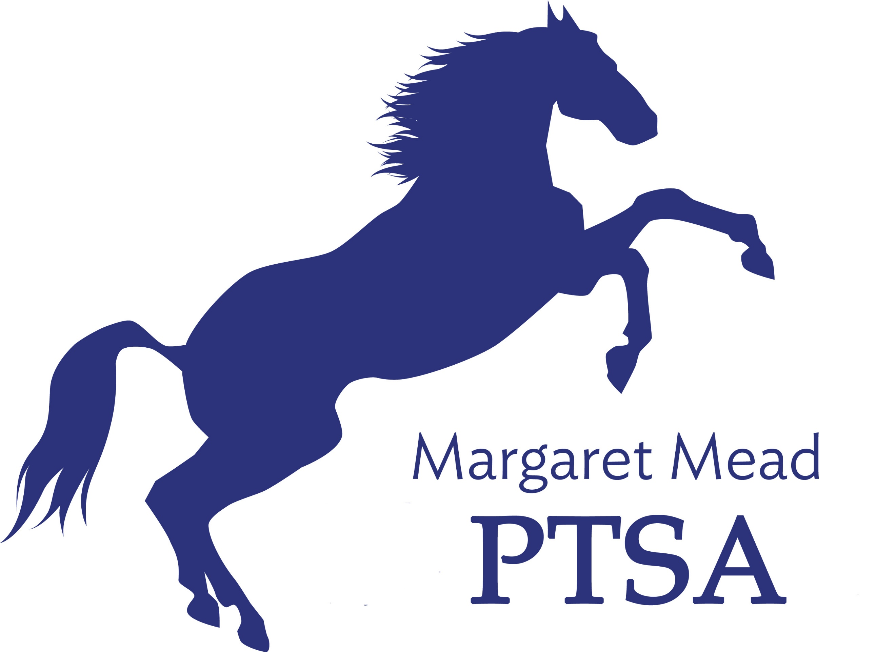
Margaret Mead Elementary PTSA
1725 216th AVE NE, Sammamish, WA 98074
PTSA Unit 2.8.38
www.meadptsa.org
Goals: Support the mission statement using:
effective communication, connecting community, financial support & fiscal responsibility.
General Membership Meeting Minutes
October 1, 2020
- Call to Order 7:02
Present: Molly Hylen, Leta Hamilton, Abi Nubla-Kung, Sarah Jensen, Sharon Wu, Sandy Klein, Sharon Mason, Suzy Khendry, Liz Moore, Ryika Hooshangi, Daniella Toledo, Cassy Patterson, Niko Olsen, Leigha Bice, Jessie Chou, Sana Aziz, Sue Gabica, Katie Heron, Ashley Arrington, Ashwini Godbole, Prarthana Kamath, Abbey, Daniyal (last 2 names listed here did not have first/last name written in their Zoom window. Secretary was unable to get their names.)
- Approval of the Minutes – May GMM minutes approved. The Standing Rules were approved in May’s GMM & reflected in those minutes (attached to this meeting’s documents in Secretary Binder).

- President’s Report: Ryika Hooshangi
- Community building is our top goal. If you have any ideas for events, email president@meadptsa.org
- Communicating with parents is our challenge & priority. Mustang Report, PTSA Website and Facebook are our main tools for communicating to our community. Pumpkin carving contest in October coming up. Thank you to our Communications team for all their hard work!
- 15% of families are members. Our goal is 100%. Join at meadptsa.org
- This year we are having a Pass the Hat fundraiser. We are also doing whatever passive fundraising we can. Amazon Smile is one passive fundraising avenue available to community members.
- Board vacancy—Legislative/Advocacy position. If interested, please let us know.

- Vice President Report: Abi Nubla-Kung
- Goals/Mission Statement – Partnering with staff & families to create a safe, healthy & inclusive learning environment to provide an enjoyable & positive school experience. We are going to add “students” at the beginning of the Mission Statement. This will be reflected on November’s Agenda.
- Reflections – I matter because … is the theme. 6 categories: film, music comp, visual arts, literature, photography, & dance choreography. 3 divisions. Two ways to submit: virtual & drop box at school. Oct 26-30 outside Mead Arts & Science Room. October 30 is deadline. We can send 15 from Mead & 6 from special division to go on to Council competition. Meadptsa.org has rules, guidelines, entry forms, & FAQs. Reflections@meadptsa.org

- Treasurer’s Report: Molly Hylen
- A few matching funds came in, in September. Membership brought in $800. We approved the budget in May. There are no changes in budget between May and October GMM.
- Beginning balance for September was $94,905.73.
- Ending balance for September is $95,796.20
- 2019-2020 Mid-Year Financial Audit – everything looked good to Audit committee thanks to efficiency of last year’s treasurer.
- Our Charitable Solicitations form for Washington state will be filed at the end of October. Our insurance is due mid-December & we will renew our current insurance coverage policy. Tax Filing will be completed with the help of an accountant.

- Principal Update – nothing to report other than staff are working extremely hard to create an educational environment in the remote learning setting that is optimal for student learning. District is preparing for the return of kindergarten and first grade, but there is no date set as of the GMM.
- Adjourn 7:25 Next General Membership Meeting-- January 14, 2021 at 7:00pm
Calendar of Events
- Sept. 28-Oct. 2: Spirit Week
- Oct. 6: Math Challenge #1 Due
- Oct. 23: Pumpkin decorating competition
- Nov. 19: Board Meeting
- Dec. 3: Talent Show Night*
- Dec. 16: Margaret Mead’s Birthday
- Dec. 17: Gingerbread House Decorating Competition*
- Jan. 14: Board Meeting and General Membership Meeting
- Jan 21: BINGO/Game Night
- Late Jan/Early Feb: Spelling Bee
- Feb. 4: Board Meeting
- March 4: International Night
- March 11: Board Meeting
- April 15: Board Meeting
- April 29: Virtual Cooking Class
- May 3-7: Teacher Appreciation Week
- May 20: Board Meeting and General Membership Meeting
- June 3: Board Meeting
- June 16: Last Day of School

